DEPI Initiative

Microsoft Machine Learning

**Down Syndrome Detection Using CNN**

**(Image Classification Approach)**

**Presented By:**

Amr Ashraf Ahmed

Abdelrahman Sameh Rashad

Asmaa Elsayed Mohamed

Kerolos Yosry Fared

Mariam Samy Nassif

1. **Problem Statement:**

**Genetic Disorder:** Down syndrome results from having an extra 21st chromosome, affecting 1 in 800 births globally.

**Physical & Developmental Characteristics:** Distinct physical traits (e.g., flat facial profile, almond-shaped eyes) and intellectual disabilities.

**Health Implications:** Associated with health conditions such as heart disease, hearing loss, and vision problems.

**Develop a machine learning model to detect Down syndrome using facial features, aiding in early diagnosis.**

**2-Project Overview:**

**1.Dataset**

* 3,000 images of children (1,500 with Down syndrome, 1,500 healthy).
* Labeled images are used to train a convolutional neural network (CNN).

**2.Features**

* Distance between eyes.
* Distance between eyes and mouth.

**3.Model**

* A CNN-based deep learning model is built to classify images as either Down syndrome or healthy.

1. **Methodology (Data Preprocessing):**
2. **Image Preprocessing:**

* Resized and normalized images.
* Split dataset into training and testing sets.

1. **Feature Extraction:**

* Features like the distance between eyes and the distance from eyes to mouth are key for classification.

1. **Class Labeling:**

* Labeled as "Down syndrome" or "Healthy."

1. **CNN Structure:**

* Input Layer: Preprocessed images.
* Convolutional Layers: Detect key patterns (e.g., shapes, facial features).
* Pooling Layers: Reduce dimensionality while preserving important features.
* Dense Layers: Fully connected layers that lead to the final classification.
* Activation Function: Relu for hidden layers, Softmax for the output layer.

1. **Training:**

* Optimizer: Adam optimizer.
* Loss Function: Binary cross-entropy.
* Early Stopping: To prevent overfitting.

1. **Methodology (Model Training and Validation) :**
2. **Metrics:**

Accuracy, AUC (Area Under Curve), Precision, and Recall.

AUC: Measures the model's ability to differentiate between Down syndrome and healthy.

1. **Evaluation:**

Training on 80% of the dataset, testing on 20%.

Best test AUC score: 0.878.

1. **Challenges**:
2. **Inconsistent Visual Features:**

Subtle differences in facial features (e.g., eye shape, facial profile) make it difficult for the model to detect consistent patterns.

**2. Feature Variability:**

Variations in lighting, quality, and angles in the images affect feature extraction accuracy.

**3. Class Imbalance:**

Although the dataset is balanced in quantity, the distinctiveness of facial characteristics for Down syndrome is subtle in some images, making it challenging for the model to distinguish between the two classes.

1. **Visualization And Validation :**

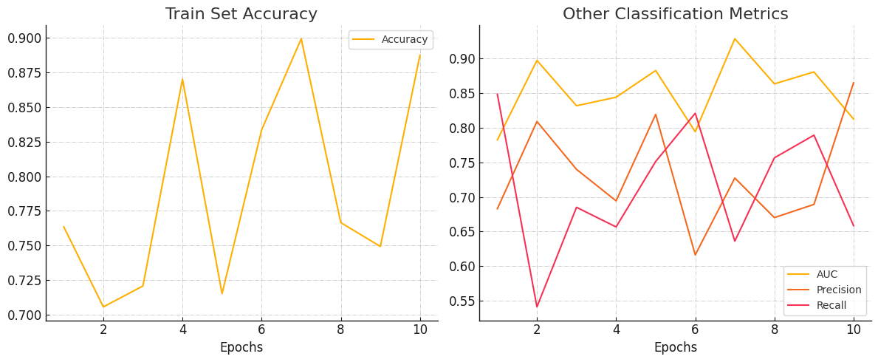



1. **Future Improvements:**

* **Incorporate Additional Features**: Beyond the distance between eyes and the distance between the eyes and mouth, additional facial features such as facial symmetry or texture-based features could be integrated to further improve the model’s detection capabilities.
* **Advanced Augmentation Techniques**: Implement more advanced data augmentation strategies like GAN-based synthetic data generation to further increase the diversity and volume of training data.
* **Multimodal Data Integration**: Combine image data with other medical or genetic data to enhance model predictions, potentially improving classification accuracy by leveraging complementary information.
* **Real-Time Detection System**: The ultimate goal would be to develop a real-time system that can analyze and classify images instantly, allowing healthcare providers to use it in clinical settings for early screening.
* **Model Interpretability**: Investigating techniques like Grad-CAM to visually explain what features the CNN is focusing on could increase the interpretability of the model, providing insights into how the model identifies Down syndrome traits.